**“Website for Highschool"**

**Ganesh S. Misal1, Ms. Shruti Sanjay Gawade2 , Ms. Rutuja Rajesh Kavade2 , Ms. Gargi Yogesh Kulkarni2 , Ms. Aboli Jagannath Jawale2, Ms. Sana Shabbir Shaikh3**

[*1gsmisal@cod.sveri.ac.in*](mailto:1gsmisal@cod.sveri.ac.in)*,* [*2ssgawade@*](mailto:2ssgawade@)*cod.sveri.ac.in ,* [*2*](mailto:2)*rrkawade@cod.sveri.ac.in ,*

2gykulkarni@cod.sveri.ac.in , [*2*](mailto:2)*ajjawale@cod.sveri.ac.in,ssshaikh@cod.sveri.ac.in*

*1Head of Department, Computer Engineering, SVERI’s College of Engineering (Polytechnic), Pandharpur, India.*

*2DiplomaStudents, Department of Computer Engineering, SVERI’s College of Engineering (Polytechnic), Pandharpur, India.*

*3Lecturer, Computer Engineering, SVERI’s College of Engineering (Polytechnic), Pandharpur, India.*

# **ABSTRACT**

*The Project is on Kawathekar High-school. It is site to view school information and many more. It would fulfill all information of latest activities conducted by High-school. It contains all the functionality which is as follows: Searching and feedback of school in our website. Internet is now a days became useful for everyone who use the internet, in addition to this; these projects will give more useful and user-friendly view to our website and user can easily get information about school. In this project I want to show how a school information can be managed with less effort and more output and can be made available to everyone who needs the access. In this project we have taken various pages and each page corresponds to a specific type of information. The main advantage for this project is to useful for a people who do not reside the same site in which the school is located and can access from any place they want. Education system forms the backbone for every nation. And hence it is important to provide a strong educational foundation to young generation to ensure the development of open minded global citizens securing the future for everyone*

***Keywords***-Website , Highschool , Education*.*

# **INTRODUCTION**

The "Website for High-school " has been developed to override the problems of users to find the school information from the villages other than cities. This web-site is supported to elimi-nate and in some cases reduce the hardship faced by this existing system. Moreover this system is designed for the particular need of people from the villages to carry out operation smooth and effective manner. The web-site is reduced as much as possible to avoid errors while entering data. No formal knowledge is needed for the user to use the system. Thus by this all it proves it is user friendly. This website as described above, can lead to error free, secure, reliable and fast management system website. Now a days information and communication technology plays a great role in different fields or areas among people. It is necessary to ensure a technologically appropriate ,affordable, efficient and environmentally adaptable and consumer friendly system. Advanced technology available today can play a crucial role in streamlining education related processes to promote solidarity among :students , teachers , parents and High-school staff. The present study aims to start answering this question by exploring the contents and structure of school websites and their responsiveness to their school's environment. In the following sections we briefly review the literature regarding school websites, describe the institutional theory that provides the conceptual framework for the study, present the study methods and findings, and finally discuss the results and suggest practical implications for accountability-oriented school website development. **.**

**LITERATURE REVIEW**

# **1.Information of the software**

# **2.We will strive for the literature and information from the internet We will make attribute from the newspapers . And in general, a literature survey guides or helps the researcher to de-fine/find out/identify a problem.**

# **a. CSS stands for CASCADING STYLE SHEETS. Styles define how to display HTML elements. Styles are normally stored in style sheets. Styles were added to HTML 4.0 to solve a problem.**

# **b. HTML was originated by Tim Berners-Lee. HTML was developed a few years ago as a subset of SGM (Standard Generalized Mark-up Language), which is a higher-lever mark-up language that has long been a favourite of the defence. Any HTML document is also valid for SGML. HTML is a Hyper Text Mark-up Language that is used to develop web pages**

# **c. The full form of PHP is Hypertext Pre-processor. Its Original name was Personal Home Page. Rasmus Lerdorf software engineer, Apache team Member is the creator and original driving force Behind PHP. The first part of PHP was developed for his personal use in late 1994.By the middle of 1997 PHP was being used on Approximately 50,000 sites worldwide. PHP is server side scripting language, which can be embedded in HTML or used stand alone.**

# **PROPOSED SYSTEM**

Nowadays, education has become a must necessity for each and every. Schools are also adopting advance technology to make students more competitive and get interest about education. Therefore, it is very necessary for every school to have their own school website. So that schools can explore their quality of education and provide proper information about school globally with the help of website. This will make easy for visitors to get information as well as admission from anywhere. Website gives proper knowledge about the facilities, structure, information about teachers, about events, mission of school, vision of school etc. 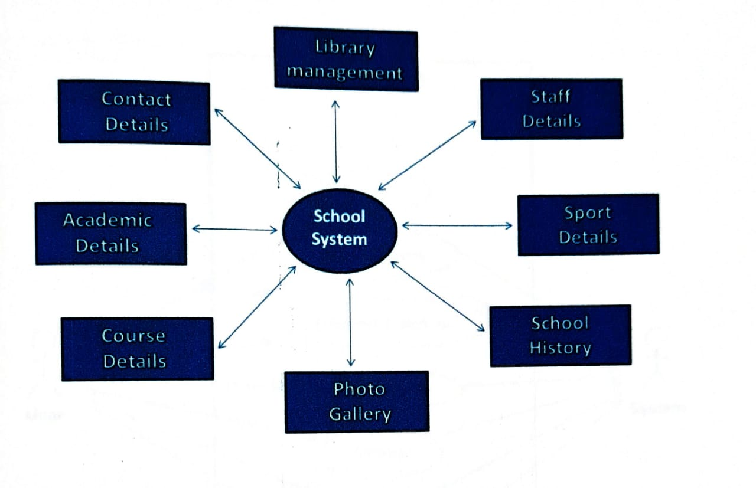

Fig. 1Highschool System

**METHODOLOGY**

* 1. Data collection, determine specification & requirement.
  2. Evaluate and choose best design.
  3. Test & Redesign accordingly.
  4. Final design.

**Implementation**

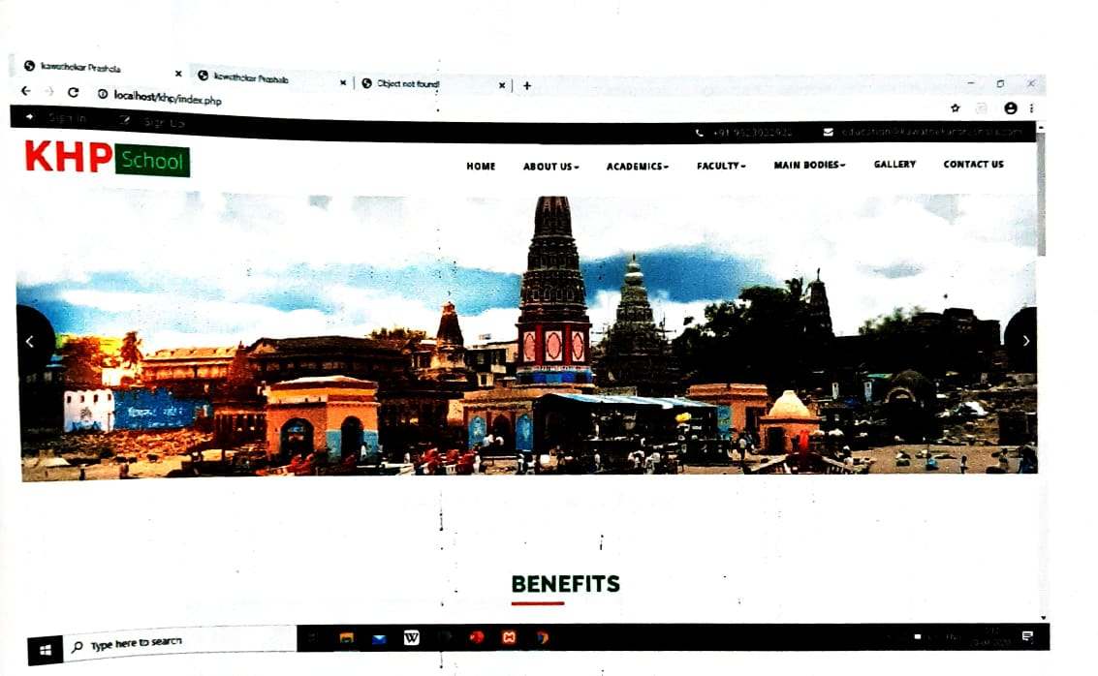

# **CONCLUSION**

User can view the information. Admin: Admin adds the new info by creating new page by adding new images of the school which can be retrieved and used whenever needed and all the validation are performed .Thus it ensures that the user cannot enter any wrong data which would cause problem later. User: This application allows the user to access all the information available.

**REFERENCES**

**[1]** [**https://ieeexplore.ieee.orghpl/opac.jsi**](https://ieeexplore.ieee.orghpl/opac.jsi)

**[2] https://www.w3schools.com/js/default. as**

**[3]** [**http://www.selcofoundation.org**](http://www.selcofoundation.org)

**[4] http://fcit .usf .edu**

[5] http://gbpssi.in/admin/coursepack/MBR517Lect05.pdf

[6] https://play.google.com/store/apps/details?id=com.darkmodeapps.invoicemaker

[7] https://play.google.com/store/apps/details?id=com.billing.systemhl=en

[8] https://play.google.com/store/apps/details?id=in.wbsedcl.sahayogi

[9] https://play.google.com/store/apps/details?id=com.bigbasket.mobileapp

[10] https://play.google.com/store/apps/details?id=in.swipe.app